TITLE (IN CAMBRIA 14 POINT – CAPS LOCK)

Presenting author¹, *Co-Authors²

¹Affiliation of Presenting author
²Affiliation of *Co-Authors, e-mail


ABSTRACT
Paper title should be written in capital letters and with central alignment (Cambria, 14 pt, bold, Caps Lock). Authors should be listed with central alignment also, without title but including the name of the institution (Cambria, 12 pt, normal). Name and surname of the corresponding author must be marked with an asterisk (*). It is necessary to indicate the e-mail address of the corresponding author.
Paper abstract should contain 200-300 words without the title and the author. Abstracts do not include figures and tables. Paper abstract should contain: introduction, methods, results and conclusions which must be written with justified margins (Cambria, 12 pt) single spaced. Original paper abstracts will not be proofread. The authors are responsible for the linguistic and grammatical correctness of the abstract in English language. Each linguistic, grammatical and scientific mistake shall be published unless eliminated by the author/s.
Keywords: 5 keywords.

INTRODUCTION
Papers for the II International Conference Global Challenges through the Prism of Rural Development in the Sector of Agriculture and Tourism (GIRR 2025) should be submitted to the following email address: girr@akademijasabac.edu.rs.
Papers which are not written in accordance with the instructions shall be returned to the authors for necessary corrections.
Accepted papers shall be published in the Conference Proceedings (containing only papers presented at the conference).
The minimum number of pages for the scientific and professional papers 8. This includes text, figures, images, tables and references.
The official language of the II International Conference Global Challenges through the Prism of Rural Development in the Sector of Agriculture and Tourism (GIRR 2025) is English. Authors are responsible for the content, validity and originality of the paper, and all other consequences that may arise from publishing it.
MATERIAL AND METHODS OF WORK
Papers should be saved in the Word 97-2003 (.doc) format. The main font should be Cambria, A4 format, each margin 2.54, single spaced. The title should be written in capital letters and centrally aligned, font size 14 pt. Full names and surnames of the authors (12 pt) should be written one single space below the title, and the full name of the institution they come from should be indicated one single space below and centrally aligned, font size 10 pt. The abstract should be written double-space below the name of the institution, in accordance with the template for the paper abstract (12 pt). Keywords are separated with commas. Subtitles should be left aligned (12 pt, bold, caps lock) with double-space above and single space below the subtitle. The scientific paper is written in 12 pt font size.

RESULTS AND DISCUSSION
It is recommended to prepare tables in Word, and graphs in Excel except for the special cases where this is not technically possible. They should also be easy to review and as simple and clear as possible. Title, heading (text) and subtext within tables and graphs should be written in Cambria – normal, 10 pt font size. Tables should be put in a specific place within the text. Tables should not contain more than ten columns and more than fifteen rows. If the author thinks that the data need to be presented in more columns or rows, then he/she must divide the content into two or more smaller tables or submit it as a special attachment. It must be prepared with “Insert table”, and not by using spaces, full-stops and tabs. Equations must be written in a graphic editor for equations, primarily in Microsoft Equation and set at the beginning of the text. On the right edge of the text, in a line in which the equation is written, there must be its number indicated in brackets. Images should be prepared for black-and-white print, i.e. if the original image is in colors which do not differ when printed in black-and-white mode, then the colors must be replaced by “raster”, i.e. different graphic signs that need to be explained through the legend. The figures should contain only the text necessary for understanding such as measurement variables with dimensions, short explanation on the curves etc. The other things should be included in the legend below the image. Maximum figure size is 13 cm x 17 cm. Illustrations (tables, figures, diagrams) should be marked. Legends, i.e. explanations of the illustrations should be numbered, whereby the number of the figure or table must correspond to the appropriate reference in the text. In figures, legend should be written below, and in tables it should be written above the text (Cambria, 10 pt).

Example of formula marking:

, (1)

Example of figure marking:
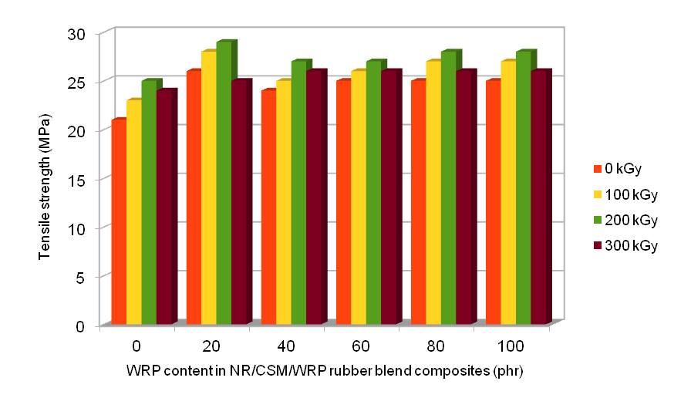
Figure 1..................................

Example of table marking:

Table1........................................
WRP content  (phr) | Curing characteristics
WRP content  (phr) | M_{l},  dNm | M_{h,}  dNm | M,  dNm | t_{s2,} min | t_{c90,} min | CRI
0 | 4 | 40 | 36 | 6 | 15 | 11.0
20 | 5 | 42 | 37 | 8 | 16 | 12.5
40 | 5 | 45 | 40 | 9 | 16 | 14.3
60 | 7 | 46 | 39 | 9 | 17 | 12.5
80 | 7 | 47 | 40 | 10 | 17 | 14.3
100 | 7 | 47 | 40 | 10 | 17 | 14.3

CONCLUSIONS
Symbols of physical quantities should be written in italics (Cambria, 12 pt. - italic) and units of measurement in ordinary letters, e.g. V, m, p, t, T, but kg, Pa, W, K. Quantities and units of measurement must be used in accordance with the International System of Units (SI).

REFERENCES
In-Text Citations

Use APA style citation, i.e. author-years citation methods. The last name of the author and the date of publication are inserted in the text in the appropriate place, in brackets. The reference list at the end of the article has to include only the sources which the author referred to in the article text. The used literature items are listed in alphabetical order.

Examples of citing

An example of citing a scientific journal

In the text:
(Avramović, 2011)
(Špírková et al., 2009)

In the reference list:
Avramović, D. (2011). Metode i okviri rasta vrijednosti banke. Anali poslovne ekonomije, 5(1), 28-37.
Špírková, M., Strachota, A., Urbanová, M., Baldrian, J., Brus, J., Šlouf, M., Kuta, A. & Hrdlička, Z. (2009). Structural and surface properties of novel polyurethane films. Materials and Manufacturing Processes, 24(10-11), 1185-1189.

An example of citing a book

In the text:
(Peterlin i Mladenović, 2007, str. 187)
(Suzić, 2010)
In the reference list:
Peterlin, J. i Mladenović, M. (2007). Finansijski instrumenti i menadžment finansijskih rizika. Banja Luka: Univerzitet za poslovni inženjering i menadžment.
Suzić, N. (2010). Prvila pisanja naučnog rada: APA i drugi standardi. Banja Luka: XBS.

An example of citing a chapter of a book

In the text:
(Harly, 1981, str. 69-78)
U popisu literature:
Harley, N. (1981). Radon risk models. U A. Knight, & B. Harrad (Ur.), Indoor air and human health (str. 69 ̶78). Amsterdam: Elsavier.

An example of citing a paper published in the Scientific Conference Proceedings

In the text:
(Krstić i sar., 2014)

In the reference list:
Krstić, M., Skorup, A. i Skorup, S. (2014). Inovativnost – ključni element preduzetničke strategije rasta i razvoja privrednog subjekta. U M. Žiravac-Mladenović, Zbornik radova sa međunarodne naučne konferencije o društvenom i tehnološkom razvoju. (str. 51-58). Banja Luka: Univerzitet za poslovni inženjering i menadžment.

An example of citing a master thesis or PhD thesis

In the text:

(Petrović, 2001)
(Žiravac-Mladenović, 2009)

In the reference list:
Petrović, R. (2001). Dehidratacija etera na mordenitnim katalizatorima. Magistarski rad. Univerzitet u Banjoj Luci, Tehnološki fakultet, Banja Luka, BiH.
Žiravac-Mladenović M. (2009). Bankarski nadzor i regulative zemalja u tranziciji na Balkanu – globalizacija bankarskog sektora. Alfa Univerzitet, Beograd, Srbija.

An example of citing a publication of an institution as the author, downloaded from the Internet and citing a text from the web site

Citing Internet sites should be avoided, but if it is necessary, then they should include names of the authors, if they are available, the title, Internet site and access date.

In the text:
(Zavod za statistiku Republike Srpske, 2009)
(Pearlin & Schooler, 2011)
In the reference list:
Zavod za statistiku Republike Srpske. (2009). Saopštenja. Preuzeto 10.02.2009. sa http://www.rzs.rs.ba/SaopstenjaRadLAT.htm
Pearlin, L., & Schooler, C. (2011). The structure of coping. Journal of Health and Social Behaviour. Retrieved March 23, 2011, from http://palgrave.jibs.1500217

